Practical-1
Task 1: Packet identification
1. total number of packets captured
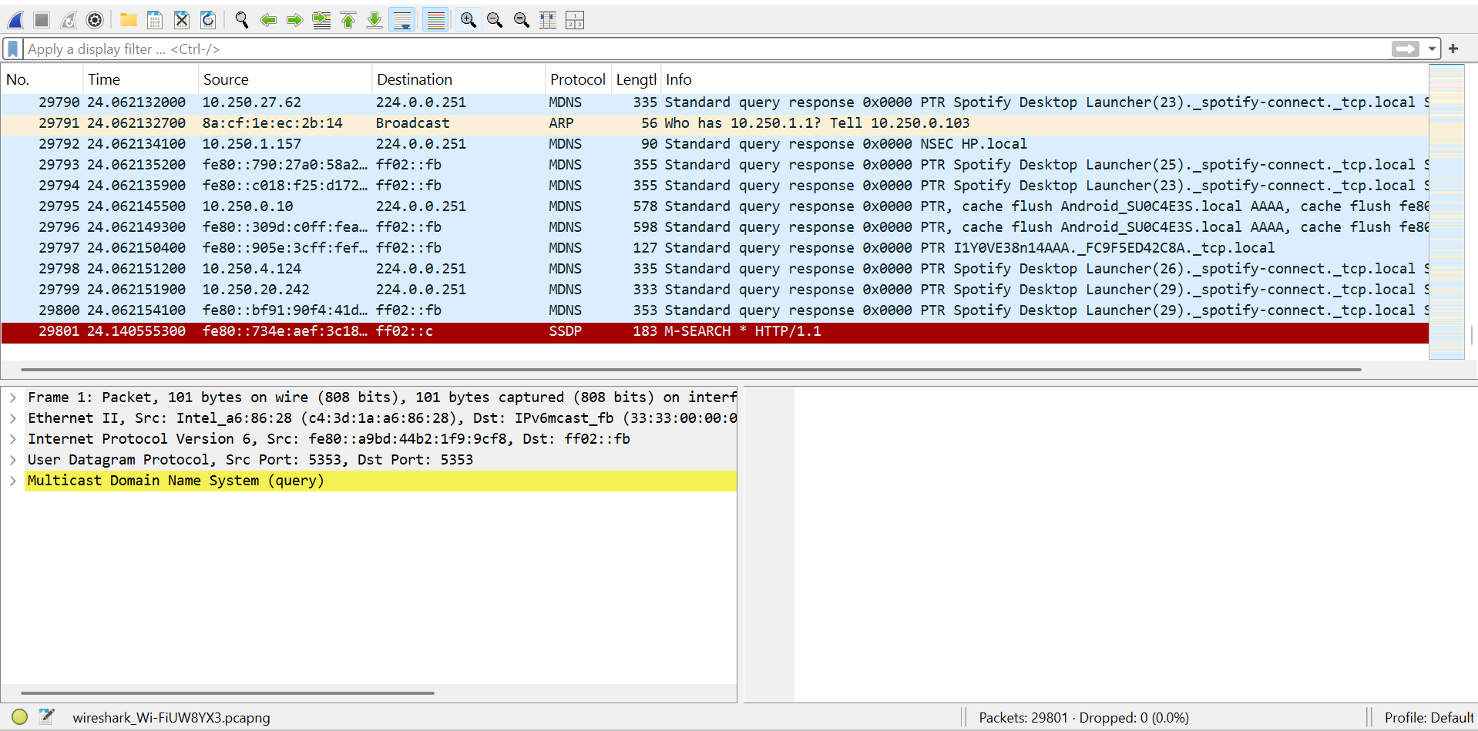
2. TCP packets
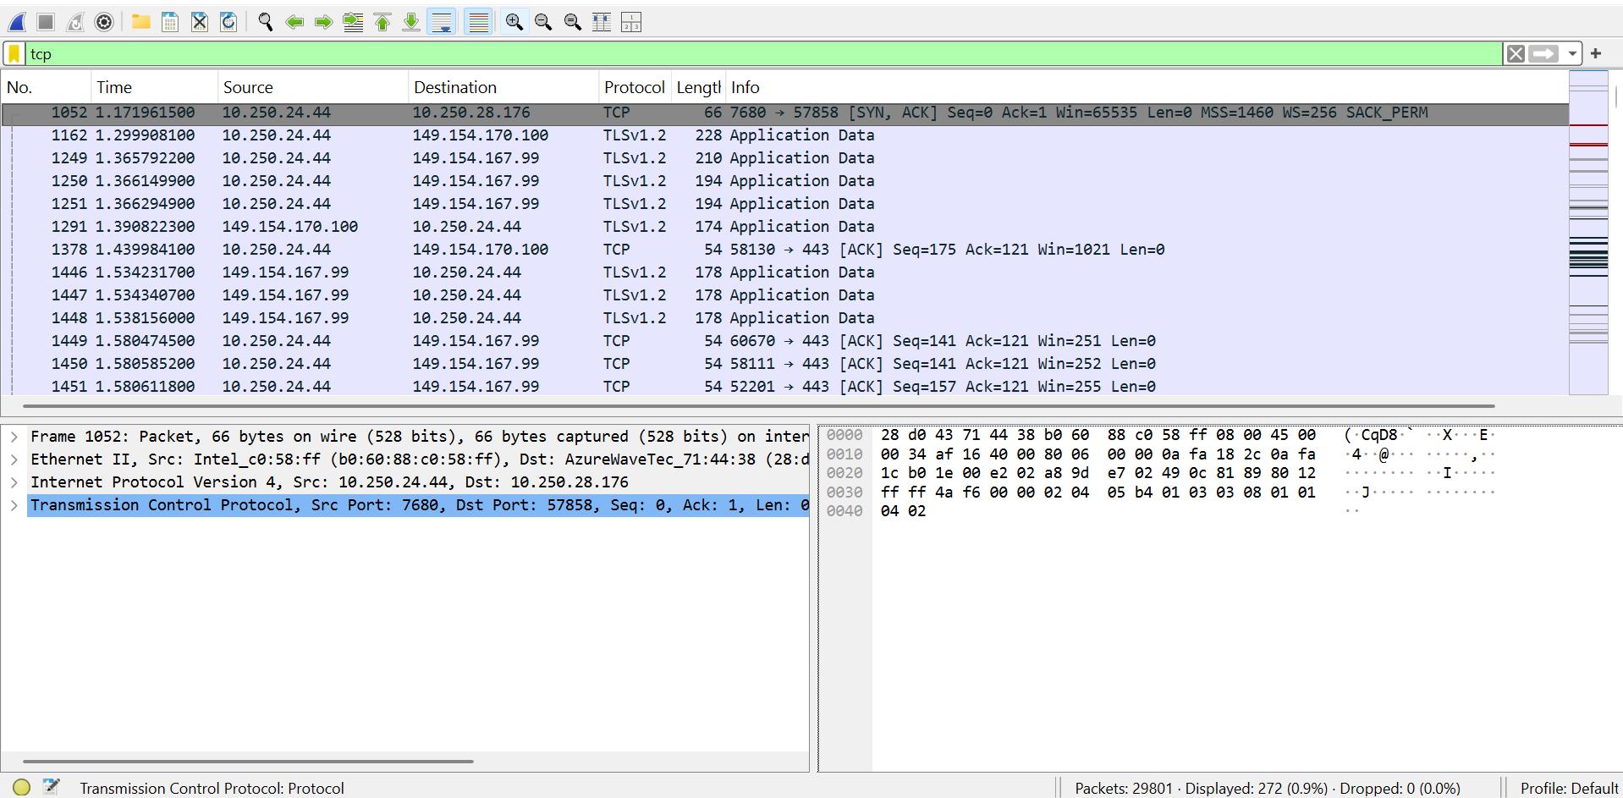
3. UDP packets
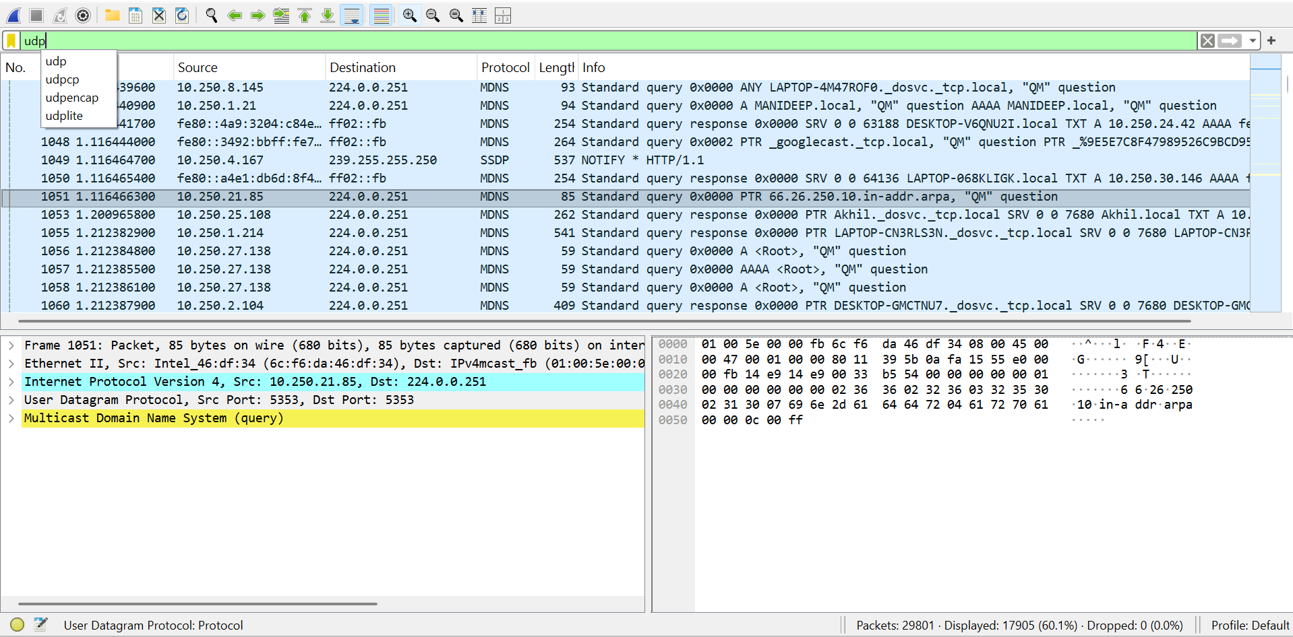
4. ICMP packets
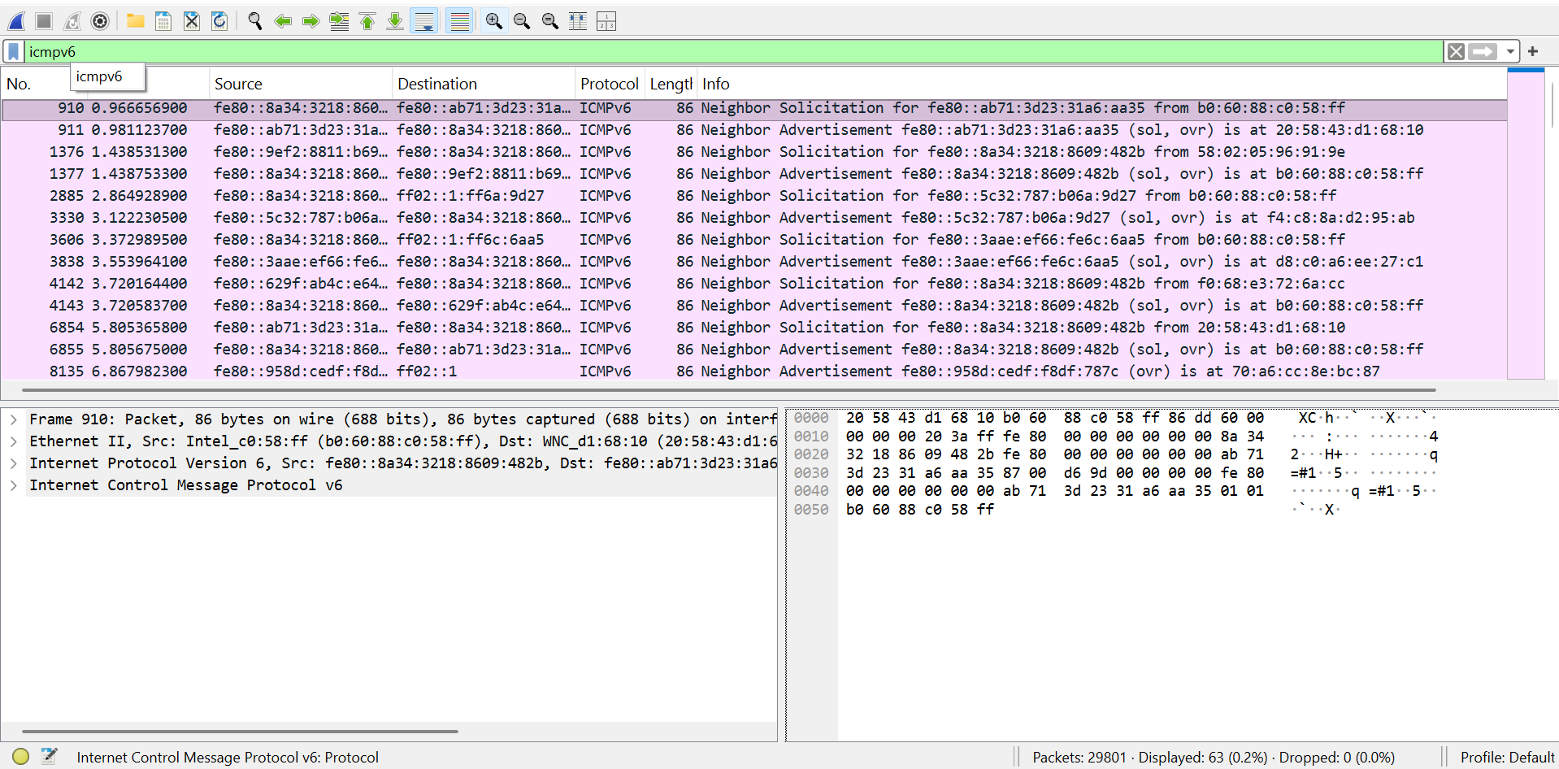
5. top five protocols

